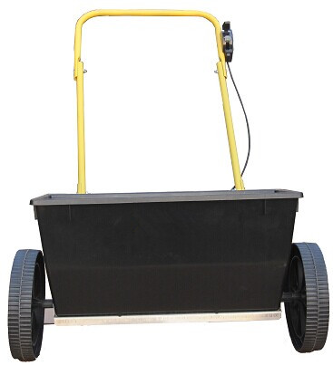

Note: Please read this owner’s manual before assembling.

Tools Required: 1 Adjustable Wrench or Pliers, 1 Screwdriver and 1 Hammer
Estimated Assembly Time: 30 minutes

Part List
Part No. | QTY | DESCRIPTION | NAME
A. | 1 | 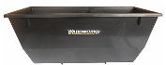 | Hopper  10.75” x 23”
B. | 1 |  | Top Handle
C. | 1 |  | Leg Stand
D. | 2 | 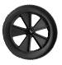 | 10” Wheel
E. | 2 |  | Side Handle
F. | 1 |  | Agitator Blade
G. | 1 |  | Axle
H. | 1 | 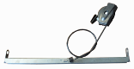 | Flow Bar w/ Control Cable Assembly
I. | 8 |  | M6X35mm Carriage Bolt
J. | 8 |  | M6 Flat Washer
K. | 8 |  | M6 Nut
L. | 2 |  | Screw
M. | 2 |  | Spacer
N. | 1 |  | Nylon Rivet
O. | 2 |  | Large Washer
P. | 2 |  | Cotter Pin
Q. | 2 | 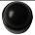 | Hub Cap

Assembly Instruction
- Remove all parts and hardware from carton and match to Parts List. When assembling, first hand-tighten all nuts and bolts, when fully assembled go back and properly tighten all nuts and bolts. DO NOT OVER TIGHTEN.

- Put the hopper (A) on a flat surface, front with logo facing away, back facing you. Put Flow Bar w/ Control Cable Assembly (H) on the bottom of Hopper (A), make sure holes in the sides of Flow Bar (H) and the Hopper (A) are aligned. Push the plastic snap on Control Cable (H) into the slot in the back of Hopper (A), and then insert Nylon Rivet (N) into the plastic snap from inside of Hopper (A).
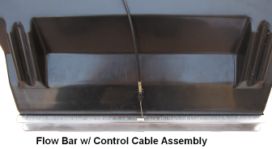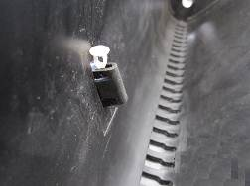
- Slide one Spacer (M) onto Axle (G) from non-flat end and slide down towards flat end. Now insert non flat end through one of the holes in Flow Bar (H) and Hopper (A), and then through the marked end of the Agitator Blade (F), finally through the other holes of Hopper (A) and Flow Bar (H). Make sure two large pop holes on Agitator Blade (F) align with two indentation holes on Axle (G). Using a Screwdriver to fasten Agitator Blade (F) to Axle (G) with 2 Screws (L)
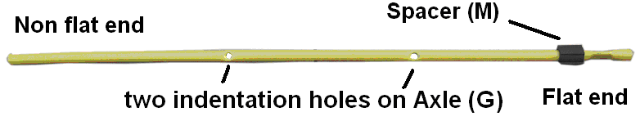
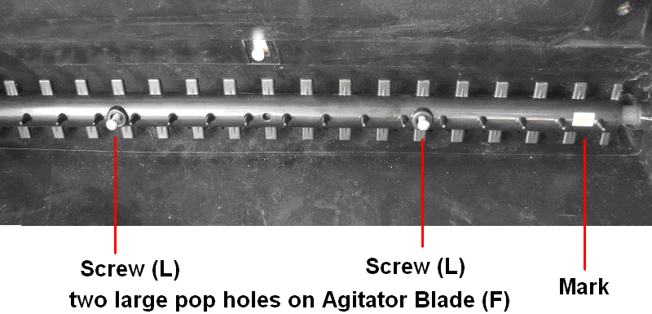
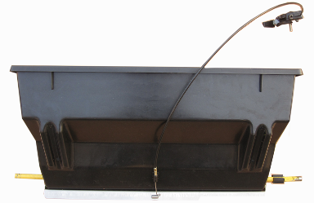
- Place the other Spacer (M) onto non flat end. Now place one Wheel (D) onto each end of Axle (G), with offset hub facing the Spacers (M), then attach 1 Large Washer (O) to each Wheel (D), using a Cotter Pin (P) to secure. Last, place Hub Cap (Q) over the Cotter Pin (P) and large Washer (Q)
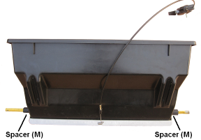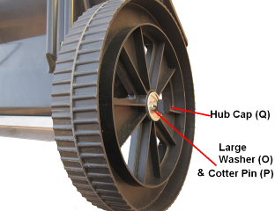
- Attach Leg Stand ( C ) to the back of Hopper (A), insert 4 M6 X35mm Carriage Bolt (I) through holes in Hopper (A) and Leg Stand (C), secure with M6 Flat Washer (J) and M6 Nut (K).
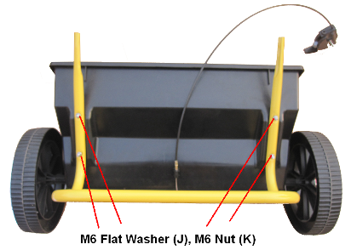
- Attach Side Handles (E) to the Leg Stands (C). Insert M6X35mm Carriage Bolt (I) through top holes of Leg Stands (C), then through indentation holes in Side Handles (E), secure with M6 Flat Washer (J) and M6 Nut (K)
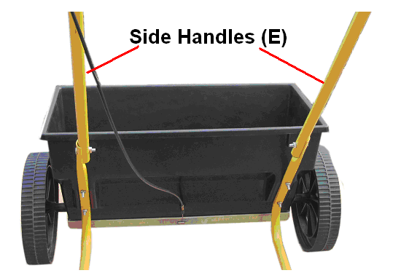
7. Attach the Top Handle (B) to the Side Handles (E). Insert M6X35mm Carriage Bolt (I) through hole of Top Handle (B), then through hole in Side Handle (E), secure with M6 Flat Washer (J) and M6 Nut (K)
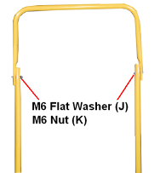
8. Unscrew the bolt, washer and nut on Control Cable Assembly (H), attach Control Cable Assembly (H) to left handle, securing with the bolt, washer and nut.
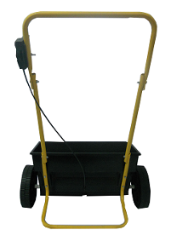
Now tighten all nuts and bolts. Do not over tighten.
Using Your Spreader

Settings are made by sliding the Calibration Indicator Button to the desired setting on the Cable Control. To begin spreading pull the control lever to the desired setting. To stop spreading, push lever to off position.
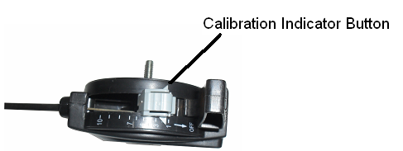
Care Instructions

- When finished using product, rinse with cold water and wipe completely dry, to prevent rust.
- Empty the hopper after each use. Do not store product with material left in the hopper.
- Lubricate all moving parts, including slide plate, axle, and center rod.

Caution: Care must be taken with any weed killer, pesticide, or combination product. These products can be harmful to other plants in your garden.

Caution: On the bag of fertilizer there should be a chart indicating the recommended settings for use. Due to the fact that different manufacturers of fertilizers make the granules different sizes it is impossible for spreader manufacturers to provide setting guidelines for all fertilizers. In addition, walking speeds and terrain may differ. Due to these differences the setting may need to be adjusted to best suit your application needs.

